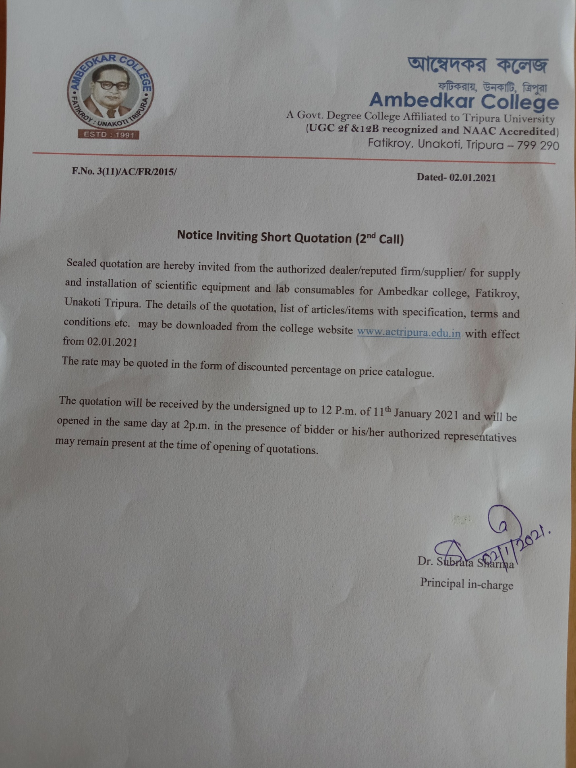
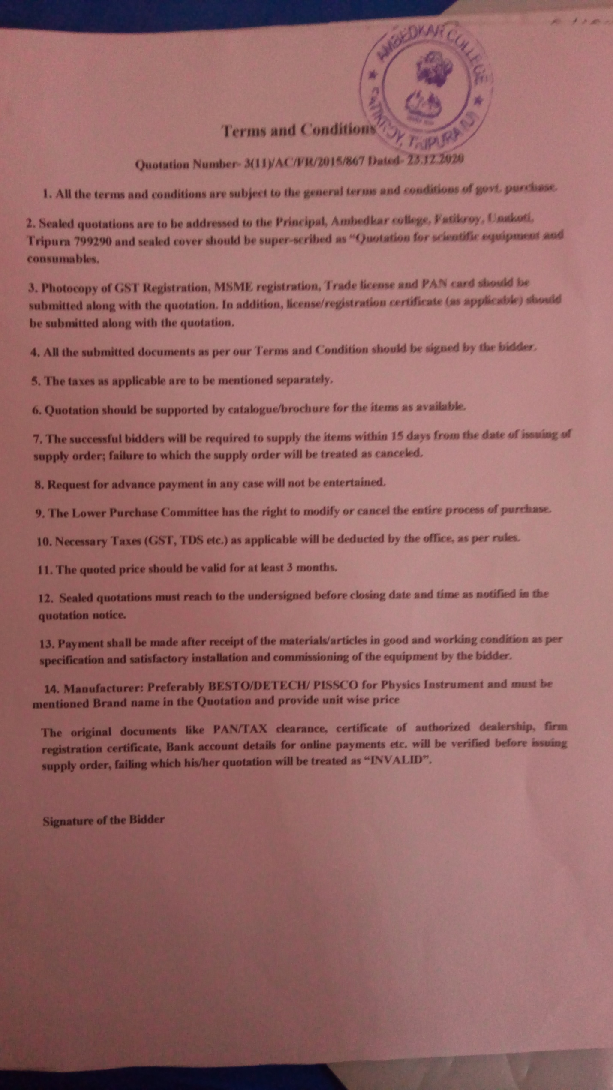
ANNEXURE-I

Requisition for Department of Physics
- Complete setup of measurement of Boiling point of a liquid by Platinum resistance thermometer
(Platinum Resistance Thermometer 3 ratio P.O. box Meter Bridge Leclance cell (dry)/ 2V Power Supply 100 ohms / 1A rheostat Dead Beat Galvanometer Lamp & scale arrangement Tapping key. Commutator Large funnel Funnel holder with stand Heating mantle (size of flask 2000ml ) Round bottom flux for Pt.Resistance Thermometer Stand for clamping the bottles)
- Complete setup of measurement of thermoemf measurement instrument
(Potentiometer with jokey[10 no wire] 2V Power Supply Resistance box 0-10000 Spot Galvanometer Plug key. 1 Way Thermocouple Copper Constantan Thermometer 110 Deg Stand for holding thermometer Arrangement for boiling of water - complete with electrical heater Ice bath - 500 ml Plastic beaker)
- Complete setup of construction of one ohm resistance
(Carry Foster Bridge 1 Ohm Manganin coil resistance Resistance Box Manganin coils 5000 ohms Standard 1 ohm coil ( Oil Cooled) 2 V DC Power Supply Plug commutator Digital Galvanometer Rheostat 100 ohms 2A)
- CRO ( Systronics, Double beam)
- Function generator (Systronics)
- Complete setup for determination of high resistance by the method of leakage
- Complete setup for determination of mutual inductance of two coils
- Study of half wave, Full wave and bridge rectification
- Rheostat - 200ohm
- Resistance box ( fractional and range 0 to 10000 ohm)
- AC Voltmeter-
- AC ammeter-
- Table Galvanometer-
- Meter bridge-
- Carrey Foster Bridge
- Potentiometer
- Constantan wire - meter
- Standard Resistance - 02 ohm, 05 ohms, 10 ohms, 20 ohms
- Connecting wire
- Power supply standard – 2 volt and 1.5 volt ( standard)
- Temperature coefficient of resistance measurement complete setup
- 1 lt boiler –
- 2 lt boiler
- Connecting Pipe
- Copper constantan thermocouple
- Screw driver set for laboratory
- One ohm standard resistance-
- P.O. BOX
Requisition for Department of Chemistry
- Viscometre
- Stalagmometer
- Stop watch
- ELECTRONIC BALANCE
- Portable Balance (with battery )
- Embedding Bath
- Electric Oven
- Rubber Pipe (20 meters) for Viscometer and Stalagmometer
- Owing bottle
- Specific gravity bottle

Requisition for Department of Zoology
Sl. No | Name of Items required | Quantity
 | BoD Bottle with Stopper(250ml) | 20nos.
 | Slides: Mite, Termite, Collembola, Ants,Daphnia, Cyclopes,Fasciola, | 1each
 | Jar Specimen: Physalia, Earthworm- PerionyxSp, Ascaris, Hirudinaria, Octopus, Exocoetus, Hyla, Hemidactylus, Chiroptera | 1each
 | Plankton net | 2nos.
 | Permanent Slide:  Prophase-I: Leptotene, Zygotene, Pachytene, Diplotene, Diakinesis, Metaphase-1, Anaphase-1, Telophase-1, Prophase-II, Metaphase-II, Anaphase-II, Telophase-II | 1each

Requisition for Department of Botany

Lab Specimen Quantity
Mucor 2nos.
Penecillium 2nos.

Permanent Slide
MucorZygospore 1no.
Penecillium Conidia 1no.

Jar Specimen
Late Blight of Potato 1no.
Stem Rot of Jute 1no.

Requisition for Chemicals, Glassware and plastic ware for all the departments.
bidders are requested to submit their bid in the form of discount percentage applicable on valid price list of the thermo fisher, SRL, CDH, Lobachem, Merck, tarson, hi-media, Qualigen, Borosil etc. bidder has to submit price catalog with the bid.

ANNEXURE-II

Terms and Conditions
- Bidder should be a trade licence from proper authority. Furnish certificate of registration.
- Rate, technical specification, Make and model no. should be mentioned properly in case of equipment’s.
- The tender should be supported with the following documents and original of the same will be verified at the time of opening of quotation.
- GST registration and Income Tax Clearance Certificate for current year.
- Authorized dealership certificate.
- Copy of PAN and GSTIN
- The bidder should have experience of setting up of similar facilities in reputed Universities/College/research institutes.
- The bidder shall bear all expenses of packaging, forwarding, freight, insurance in connection with delivery, repairs and replacements made within the warranty, period.
- The vendor shall be responsible for any loss, damage, breakage etc in transit site.
- The vendor shall bear the expenses which may incur while unloading of items, deployment of unskilled labour during installation.

- The vendor shall be fully responsible for the performance of all components of the materials and any defective material shall be replaced by the vendor free of cost during the warranty period.
- The bidder shall clearly specify their post-sale service option during the warranty period.
- The bidder shall sign all the pages of the bid.
- The vendor should have their own bank account in the name of the registered agency.
- Each quotation must be accompanied with EMD (2% to total quoted value) valid for a period of 180 days. Quotations received without Earnest Money Deposit is liable to be rejected.
- The Earnest Money of all unsuccessful tenderers will be returned as early as possible after the expiration of the period of the bid validity. No interest will be paid by this college on the Earnest Money Deposit.
- Sealed quotations are to be addressed to the principal, Ambedkar College, Fatikroy, Unakoti, Tripura.
- 100% Payment will be made after the proper supply, successful installation and demonstration as applicable.
- Request for advance payment in any case will not be entertained.
- The college authority has the right to modify or cancel the entire process of purchase.
- Necessary Taxes will be deducted by the office, if required.

Dr. Subrata Sharma
Principal in-charge

